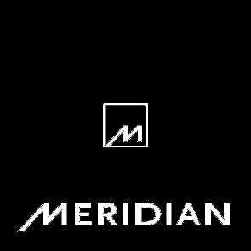

Meridian America Fixed Pricing Repair Schedule

Product  Category | Repair Cost | Unit of Measure | Models | Notes
Active  LoudSpeaker | 450.00 | Per Speaker | M33, M420, M60, SW2500, SW1500 | All versions of  listed units. Older units no longer repaired.
DSP LoudSpeakers | 750.00 | Per Speaker | D33, D420, D3100, D5K, D5.2K, D6K, D7K, D8K | D600 & D6000  (non DSP) not repairable, no parts available, D5K, D6K, D7K limited repairability due to limited parts.
Amplifiers | 500.00 | Per Channel | C50, C51, C52,  G41, G55, G56, G57, 557, 558,  559 | All versions of  listed units. Older units no longer repaired.
CD Players | 450.00 | Per Unit | 808, G06, G08 | All versions of listed units. Older units no longer repaired.
DVD Players | 950.00 | Per Unit | 800, G96, G98, G91, G95 | All versions of listed units. Older  units no longer repaired.
F80 / AD88 | 450.00 | Per Unit | F80 / AD88
PreAmp / Multimedia Controllers / Receivers | 300.00 | Per Unit | G01, G02, 501,  502, 518, 562 | All versions of listed units. Older units no longer repaired.
Sooloos | 500.00 | Per Unit | Control1,  Source1, Source5, Store1, Store2
Surround  Controllers | 850.00 | Per Unit | 861, C61R, G68, G61, 561, 568 | All versions of  listed units. Older units no longer repaired.
Video Processors | 450.00 | Per Unit | MF1080, DVP1080, DVP2351 | All versions of  listed units. Older units no longer repaired.
Video Projectors | Per Quote Only | Per Unit | 1080pHD, MF1, MF2, MF10, 810 | All versions of  listed units. Older units no longer repaired.

